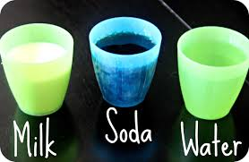

“Eggsperiment” Prediction Checklist
and
Lesson Review Checklist
Name: | Made Prediction about Milk | Made Prediction about Soda | Made Prediction about Water | A new tooth comes in when we lose a baby tooth | Not taking care of our teeth causes cavities.
1.
2.
3.
4.
5.
6.
7.
8.
9.
10.
11.
12.
13.
14.
15.
16.
17.
18.
19.
20.
21.

