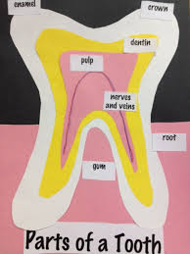

Parts of a Tooth Checklist

Name: | Placed  Dentin | Placed  Enamel | Placed  Nerves and Veins | Placed  Root | Placed  Pulp | Placed  Crown | Labeled  Dentin | Labeled  Enamel | Labeled  Nerves  And Veins | Labeled  Root | Labeled  Pulp | Labeled  Crown | Labeled  Gums
1.
2.
3.
4.
5.
6.
7.
8.
9.
10.
11.
12.
13.
14.
15.
16.
17.
18.
19.
20.
21.

