Day 1 | Day 2 | Day 3 | Day 4 | Day 5 | Day 6 | Day 7
Date:  2/24/14  Time:  35-40 Minutes  Topic:  Types of Teeth  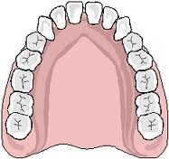 | Date:  2/25/14  Time:  35-40 Minutes  Topic:  An Up Close Look at Our Teeth  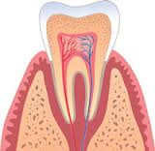 | Date:  2/26/14  Time:  35-40 Minutes  Topic:  Why Should We Care for Our Teeth?  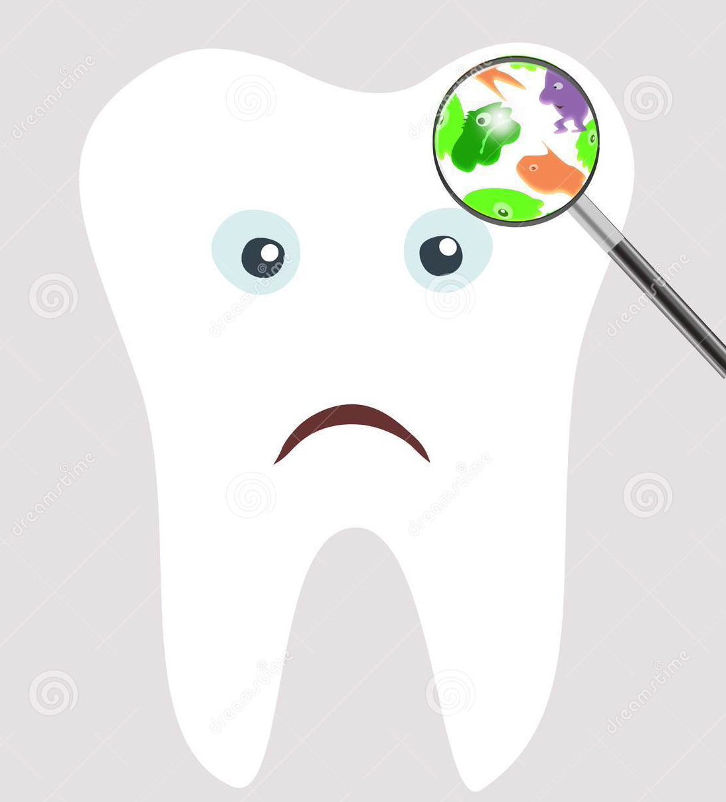 | Date:  2/27/14  Time:  35-40 Minutes  Topic:  Food and Our Teeth  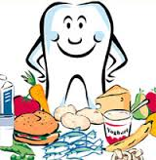 | Date:  2/28/14  Time:  35-40 Minutes  Topic:  Brushing Our Teeth  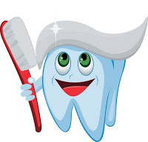 | Date:  2/3/14  Time:  35-40 Minutes  Topic:  The Dentist | Date:  3/5/14  Time:  35-40 Minutes  Topic:  Putting It All Together  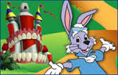
Book:  “The Tooth Book”  Activity:  “Totally Teeth”  **Introduce Verb Chart | BooK:  “What if You Had Animal Teeth”  Activity:  Build A Tooth  Online Resource:  Children’s University of Manchester  ** Cut a hole in the apple | BooK:  “Hippo’s Tooth Surprise”  Activity:  Effects of Plaque Observation  Inquiry:  “How different drinks effect our teeth” | Book:  “Hippo’s Tooth Surprise”  Activity:  Good and Bad Food Sort  (Performance Assessment) | BooK:  “I Know Why I Brush My Teeth”  Inquiry:  Check predictions from “How different drinks effect our teeth”  “Will Brushing Save Our Teeth” | Book:  “Zack Goes to the Dentist”  Activity:  Sequencing of steps in brushing  “Can, Have, Are”  A trip to the dentist indpendent sequence. | Movie:  “Dr. Rabbit and The Legend of Tooth Kingdom”  Activity:  Health Teeth Super Hero  Summative Assessment

