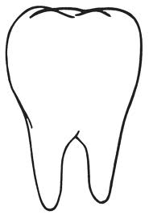

________________ is bad for my teeth.

___________________ is good for my teeth.

